USE CASE Diagram System
get emotions
Actor
Show
visuals

USE CASE 1
Name | Show happy visual
Summary | Actor shows a happy emotion
Actor | User
Assumption | Program is running
Description | - User stands in front of a camera  - Systems waits for the emotion  - User shows the happy emotion  - System detects the emotion  - System shows the visuals for happy emotion  - End of use case.
Exception | 1a: user go out of the frame  - System does not show anything  - Return to UC 1.  2a: users do not show any emotions  - System detects the neutral emotion  - System shows neutral visualisation  - Return to UC 2
Result | A happy visual is shown.
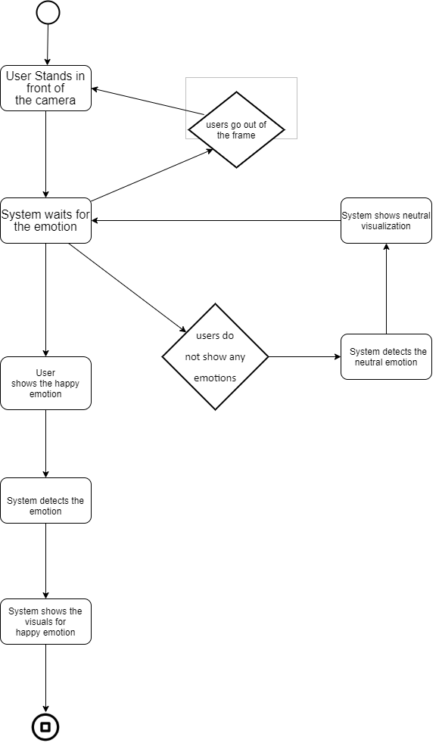
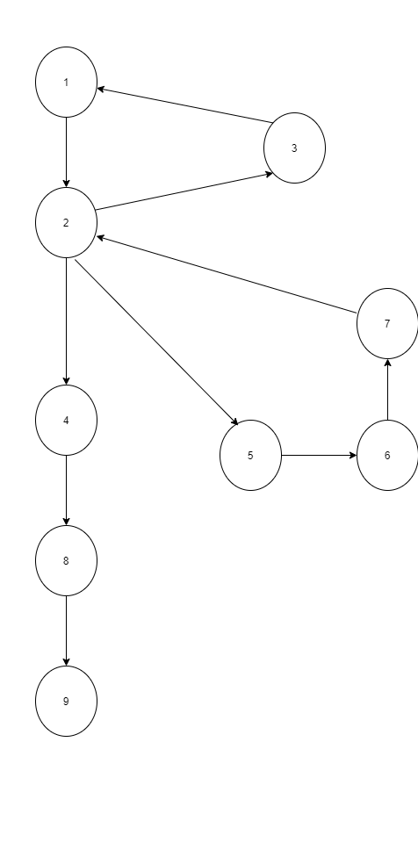
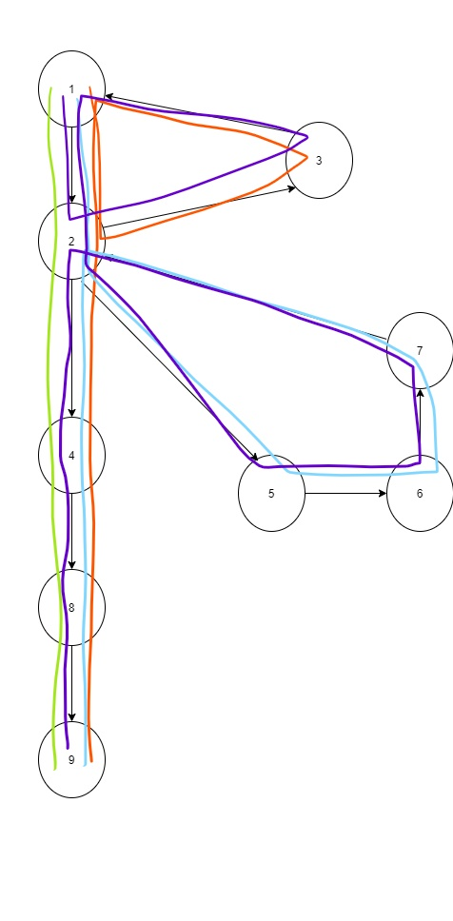

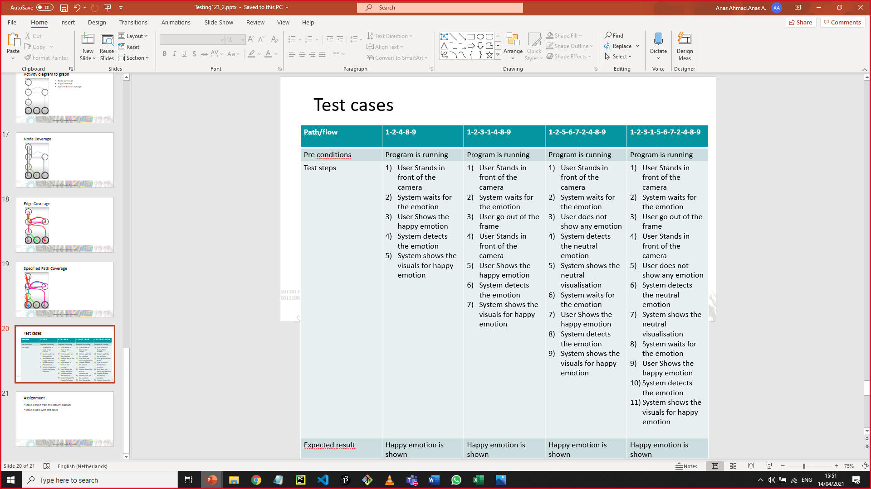
USE CASE 2
Name | Show angry visual
Summary | Actor shows an angry emotion
Actor | User
Assumption | Program is running
Description | - User stands in front of a camera  - Systems waits for the emotion  - User shows the angry emotion  - System detects the emotion  - System shows the visuals for angry emotion  - End of use case.
Exception | 1a: user go out of the frame  - System does not show anything  - Return to UC 1.  2a: users do not show any emotions  - System detects the neutral emotion  - System shows neutral visualisation  - Return to UC 2
Result | An angry visual is shown.

USE CASE 3
Name | Show sad visual
Summary | Actor shows a sad emotion
Actor | User
Assumption | Program is running
Description | - User stands in front of a camera  - Systems waits for the emotion  - User shows the sad emotion  - System detects the emotion  - System shows the visuals for sad emotion  - End of use case.
Exception | 1a: user go out of the frame  - System does not show anything  - Return to UC 1.  2a: users do not show any emotions  - System detects the neutral emotion  - System shows neutral visualisation  - Return to UC 2
Result | A sad visual is shown.

USE CASE 4
Name | Show surprise visual
Summary | Actor shows a surprise emotion
Actor | User
Assumption | Program is running
Description | - User stands in front of a camera  - Systems waits for the emotion  - User shows the surprise emotion  - System detects the emotion  - System shows the visuals for surprise emotion  - End of use case.
Exception | 1a: user go out of the frame  - System does not show anything  - Return to UC 1.  2a: users do not show any emotions  - System detects the neutral emotion  - System shows neutral visualisation  - Return to UC 2
Result | A surprise visual is shown.

USE CASE 5
Name | Show neutral visual
Summary | Actor shows a neutral emotion
Actor | User
Assumption | Program is running
Description | - User stands in front of a camera  - Systems waits for the emotion  - User does not show any emotion  - System detects the emotion  - System shows the visuals for neutral emotion  - End of use case.
Exception | 1a: user go out of the frame  - System does not show anything  - Return to UC 1.  2a: user shows any emotion  - System detects the emotion  - System shows the specific visualisation  - Return to UC 2
Result | A neutral visual is shown.

